**ARRIVÍ, FRANCISCO (1915-2007)**

Francisco Arriví was instrumental in developing a modern theatre in Puerto Rico during the 1940s-1960s. A playwright, poet, essayist, and tireless promoter of Puerto Rican culture, Arriví authored dramatic scripts for the stage, radio, and television, founded theatre groups, and supervised the theatre wing of the Puerto Rican Culture Institute. Arriví wrote several major essays on Puerto Rican theatre as well as plays ranging from poetic realism to absurdist fantasy and farce. His dramas employ anti-mimetic techniques to treat social themes from a psychological perspective. *Vejigantes* [Carnival Masks] (1958), his major play, is part of a trilogy that addresses Puerto Rican racial prejudice.

Arriví was born in San Juan. As a child, he attended the theater frequently with grandmother, and he staged children’s stories with his playmates on a small stage he built in his backyard. He studied Spanish and Latin American Literature at the University of Puerto Rico, where he is remembered for having composed the official university hymn. In the 1940s, Arriví worked as a teacher and became active in Puerto Rican theater directing plays, translating works for the university theater, and writing his first three-act dramas. He also founded the Tinglado Puertorriqueño in 1945, a company in which many of Puerto Rico’s future leading actors had their first significant roles.

Arriví’s work in Puerto Rican television and radio was decisive in his evolution as a theatre practitioner. He collaborated with an educational program sponsored by the Department of Education called Escuela del Aire (Airwave School) broadcast over WIPR Radio. His show *De la jungla al rascacielos* (From the Jungle to the Skyscrapers), which featured many of his radio dramas, was considered the best radio programme on the island. Another important influence in his training in the dramatic arts was the informal schooling he received seeing plays by Tennessee Williams, Eugene O’Neill, and Arthur Miller in New York City while studying drama and radio at Columbia University on a Rockefeller scholarship in 1949. Upon returning to San Juan he wrote *Ayer y Hoy* (Yesterday and Today) in 1951, the first television program transmitted in Puerto Rico. His work in 1956 on an Institute of Puerto Rican Culture project to foment a national theatre culminated in the creation of a theatre wing for the institute, which he directed from 1959-1970, and the establishment of the annual Festival of Puerto Rican Theatre.

Arriví’s work as a playwright began with poetic dramas such as *Alumbramiento* (Birth) (1945) and *María Soledad* (1947). His trilogy *Máscara Puertorriqueña* (Puerto Rican Mask) (1971) continues in the line of symbolic realism and consists of *Vejigantes*, *Sirena* (Siren) (1959), and *Bolero y plena* (1956). These pieces create memorable female protagonists and perform a social critique by unmasking Puerto Rico’s repressed African heritage. His *Cóctel de don Nadie* (Mr. Nobody’s Cocktail) (1965), by contrast, experiments with Theater of the Absurd. Arriví also published books of poetry and important collections of essays on Puerto Rican theatre, including *Areyto mayor* (1966) and *Conciencia Puertorriqueña del Teatro Contemporáneo, 1937-56* (1967). Through his pioneering work in drama and radio, his public lectures and essays on Puerto Rican theatre, and his efforts as an arts administrator, Arriví accomplished more than any other figure in Puerto Rico to build a modern national theatre.

**List of works**

Arriví, Francisco. (1959) *Vejigantes. Drama en tres actos de la trilogía Máscara puertorriqueña*, San Juan: Editorial Tinglado Puertorriqueño.

--------- (1962) *María Soledad*, San Juan: Editorial Tinglado Puertorriqueño.

--------- (1966) *Areyto mayor*, San Juan: Instituto de Cultura Puertorriqueña.

--------- (1966) *Cóctel de Don Nadie (Guiñolada en Cuatro Espantos)*, Barcelona: Rumbos.

--------- (1967) *Conciencia Puertorriqueña del Teatro Contemporáneo, 1937-1956*, San Juan: Instituto de Cultura Puertorriqueña.

--------- (1971) *Máscara puertorriqueña*, Río Piedras: Editorial Cultural.

--------- (2000) *Tres obras de Teatro (Alumbramiento, Caso del Muerto en Vida, Un Cuento de Hadas*), San Juan: Instituto de Cultura Puertorriqueña.

**References and further reading**

Morfi, Angelina. (1980) *Historia crítica de un siglo de teatro puertorriqueño*, San Juan: Instituto de Cultura Puertorriqueña.

Rivera de Álvarez, Josefina. (1983) *Literatura puertorriqueña: Su proceso en el tiempo*, 1983.

Stevens, Camilla. (2004) *Family and Identity in Contemporary Cuban and Puerto Rican Drama*, Gainesville: University Press of Florida.

**IMAGES**

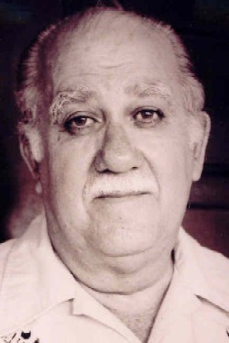

SOURCE: [enciclopediapr.org](http://r.search.yahoo.com/_ylt=AwrB8p57YCdTpi8Apu6jzbkF;_ylu=X3oDMTBtdXBkbHJyBHNlYwNmcC1hdHRyaWIEc2xrA3J1cmw-/RV=2/RE=1395118332/RO=11/RU=http%3a%2f%2fenciclopediapr.org%2fesp%2farticle.cfm%3fref%3d06100601%26page%3d4/RK=0/RS=wUU41nodoNHVCBhIol2wolGIk04-) (Available on many sites)

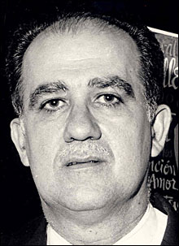

SOURCE: [karla7.wordpress.com](http://karla7.wordpress.com/) (Available on multiple sites)

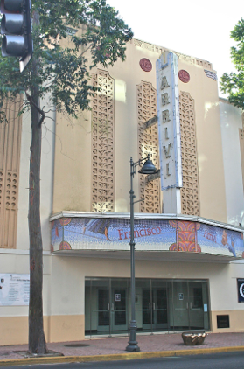

SOURCE: <http://artdecopr.org/PRADS/Matienzo.html>

Teatro Francisco Arriví, Santurce

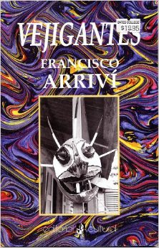

[editorialculturalpr.com](http://editorialculturalpr.com/web/catalogo.cfm?start=177&page=12" \t "_blank)

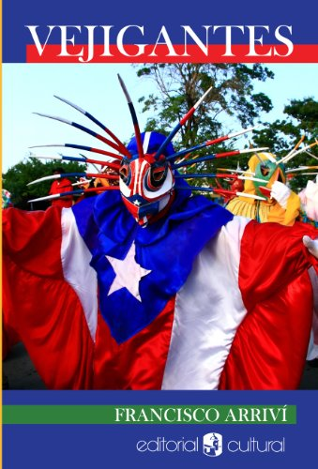

[alikewise.com](http://r.search.yahoo.com/_ylt=AwrB8pXpdlpTxVYAmySjzbkF;_ylu=X3oDMTBtdXBkbHJyBHNlYwNmcC1hdHRyaWIEc2xrA3J1cmw-/RV=2/RE=1398466410/RO=11/RU=http%3a%2f%2falikewise.com%2fbooks%2fdetails%2f22798/RK=0/RS=ZqZDNU.8wc1EMElOrERaqvyHiTQ-)

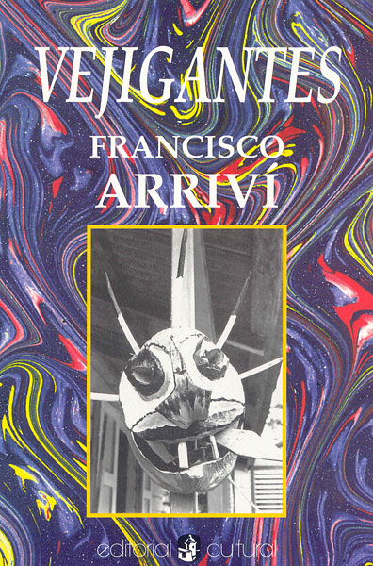

The smaller image above shows a price tag

[editorialculturalpr.com](http://r.search.yahoo.com/_ylt=AwrB8pXpdlpTxVYAnSSjzbkF;_ylu=X3oDMTBtdXBkbHJyBHNlYwNmcC1hdHRyaWIEc2xrA3J1cmw-/RV=2/RE=1398466410/RO=11/RU=http%3a%2f%2feditorialculturalpr.com%2fweb%2fcatalogo.cfm%3fstart%3d177%26page%3d12/RK=0/RS=c17t7lvK_hUimdf19IbMsbURR0Q-)